QUANTITATIVE MODULE
Transportation Models

Discussion Questions
1. Three information needs of the model: the origin points and the capacity or supply per period at each; the destination points and the demand per period at each; and the cost of shipping one unit from each origin to each destination.
2. Steps in the intuitive method are:
- Step 1: Identify the cell with the lowest cost. Break any ties for the lowest cost arbitrarily.
- Step 2: Allocate as many units as possible to that cell without exceeding the supply or demand. Then cross out that row or column (or both) that is exhausted by this assignment.
- Step 3: Find the cell with the lowest cost from the remaining (not crossed out) cells.
- Step 4: Repeat steps 2 and 3 until all units have been
allocated.
3. The three steps in the northwest corner method are:
- Step 1: Exhaust the supply of each row before moving down to the next row.
- Step 2: Exhaust the demand requirements of each column before moving to the next column on the right.
- Step 3: Check that all supply and demand constraints
are met.
4. An optimal solution has been reached when all improvement indices (profits) are non-negative (non-positive).
5. The intuitive method will usually provide a better initial solution than the northwest corner solution, but neither suggests an optimal solution.
6. The number of cells used is m + n – 1; the number of possible routes available is m × n. Example: for a 2 × 3 problem, 4 of
6 routes will be used, for a 5 × 6 problem, 10 of 30 routes will
be used. (m = rows, n = columns)
7. Nothing prohibits the model from applying over short distances. The three assumptions do not address issues of scale. An office could easily offer several sources of shipments, as well as several destinations for shipments. A job shop could easily use this model.
8. A “northeast corner” rule would be directly analogous to the northwest corner rule, but it would simply begin in the upper-right corner instead of the upper-left corner. This initial solution is degenerate because only four squares (instead of the expected five) are occupied. The degeneracy condition, by the way,
is just a peculiarity of the Arizona Plumbing Corporation data.
9. Total supply is not equal to total demand in an unbalanced transportation problem. Such a problem can be balanced by adding
a dummy row (supply < demand) or column (demand < supply).
10. Solutions must use m + n − 1 cells, where m = number of rows and n = number of columns.
11. A negative index represents the amount by which total transportation costs could be decreased if one unit of product were shipped by the source–destination combination.
12. Production costs can be added to transportation costs in each source, and the problem can then be solved as usual.
13. Degeneracy means there is no closed path from any unused square back to the original unused square via squares that are currently being used. Special techniques are needed to compute the improvement indexes.
End-of-Module Problems
C.1 (a) N.W. corner starting points:
 | Los Angeles | Calgary | Panama City
Mexico City | 50 | 50
Detroit |  | 30 | 30
Ottawa |  |  | 40
Total cost of N.W. corner method = $300 + 900 + 390 + 570
+ 960 = $3,120.
(b) Intuitive lowest-cost starting point:
 | Los Angeles | Calgary | Panama City
Mexico City | 50 |  | 50
Detroit |  | 40 | 20
Ottawa |  | 40
Total cost of intuitive method = $300 + 400 + 520 + 380
+ 400 = $2,000.
(c) Stepping-stone method:
 | After 4 Iterations | Los Angeles | Calgary | Panama City
 | Mexico City | 30 |  | 70
 | Detroit | 20 | 40
 | Ottawa |  | 40
Multiple optimal solutions exist
Cost after 2nd iteration = $2,640, after 3rd iteration = $2,160,
optimal at $2,000.
C.2
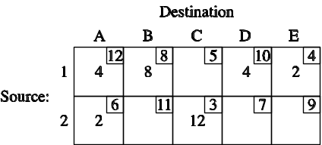

Cost = $48 + 64 + 40 + 8 + 12 +36 = $208
C.3 (a) First, compare total demand and total supply. Introduce a dummy destination to balance. N.W. corner approach:
 | A | B | C | Dummy | Supply
X | 50 | 50 |  |  | 100
Y |  | 30 | 20 |  | 50
Z |  |  | 50 | 25 | 75
Demand | 50 | 80 | 70 | 25 | 225
Cost = $2,670 (note the dummy is needed to balance).
(b) Intuitive lowest-cost approach:
 | A | B | C | Dummy | Supply
X | 50 | 30 | 20 |  | 100
Y |  |  | 50 |  | 50
Z |  | 50 |  | 25 | 75
Demand | 50 | 80 | 70 | 25 | 225
An alternate least-cost solution is
X-B = 5, ×-Dummy = 25, Z-B = 75, and Z-Dummy = 0.
Cost = $2,630 (note the dummy is needed to balance).
Intuitive approach yields a better starting point.
(c) Stepping-stone method = 3rd iteration is optimal with cost = $2,570
 | A | B | C | Dummy
X | 50 |  | 50
Y |  | 50
Z |  | 30 | 20 | 25
C.4 The only cell with a negative cost improvement index is Houston–Miami. It achieves a –1. Allocate 10 to that cell. The result is:
 | Denver | Yuma | Miami
Houston | 0 | 0 | 10
St. Louis | 20 | 0 | 0
Chicago | 0 | 20 | 10
Total cost = $170
C.5 The optimal cost = $14,700
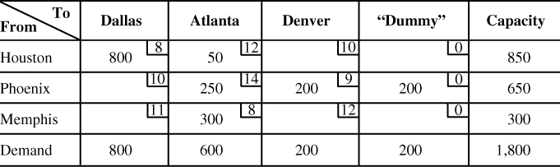
C.7 Application of the stepping-stone method will yield the following solution. The optimal cost is $2,020.
C.21 (a) Transportation table with dummy plant, initial solution
by Northwest Corner:
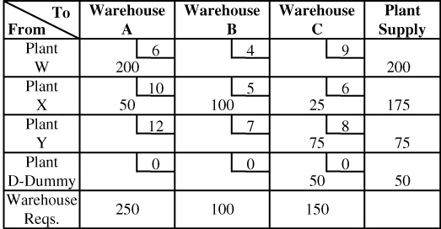
(b) Stepping-Stone Method:
Improvement indices:
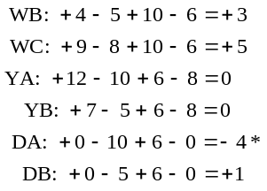
* Indicates that an improvement can be made. Note that the
most we can move around this route is 50 units.
Using route DA, we get
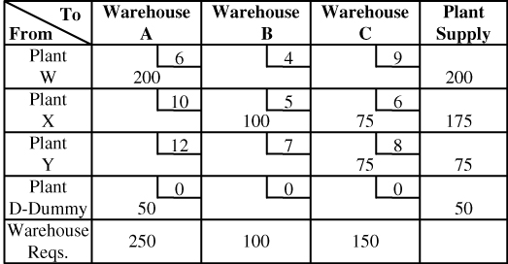
This solution is degenerate. To test for optimality, place
a 0 in one of the unused squares and apply the Stepping-
Stone method. Assume that the 0 is placed in XA:
Because all improvement indices are positive, the
initial solution is also the optimal solution.
Total cost = 200 × 6 + 0 × 10 + 100 × 5 + 75 × 6
+ 75 × 8 + 50 × 0 = $2,750

C.6 (a) The result of the next iteration is:
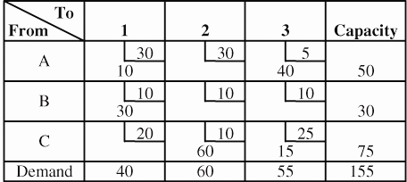
(b) Total cost if this solution is accepted as final: $1,775.
C.8 Initial solution–Northwest corner rule
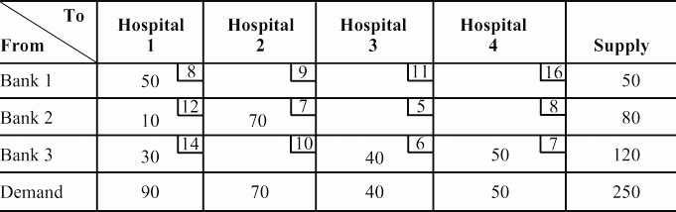

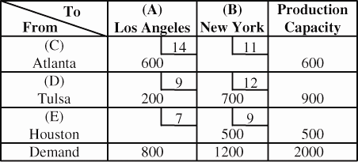
Improvement indices:
CB → + 11 – 12 + 9 – 14 = – 6*
EA → + 7 – 9 + 12 – 9 = + 1
* Indicates an improvement can be made. Therefore, this iteration is not optimal.
Evaluation of the unfilled cells reveals the following cell indices: A-2, $40; B-1, –$40; B-3, –$15; C-1, –$30; B-1 should be selected next; 30 units can be moved.

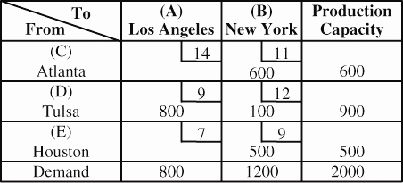
Improvement indices:
CA → + 14 – 11 + 12 – 9 = + 6
EA → + 7 – 9 + 12 – 9 = + 1
All improvement indices are positive, therefore, an optimal has been reached.
Total cost = 600 × 11 + 800 × 9 + 100 × 12 + 500 × 9
= $19,500
Comparing the firm’s total cost with that using New
Orleans ($20,000), one would recommend that, other factors being equal, the Houston site be selected.

C.9 Supply = 220 + 300 + 435 = 955
Demand = 160 + 120 + 200 + 230 = 710
Therefore, we first add a dummy destination with a demand of 955 – 710 = 245 and shipping costs of $0.
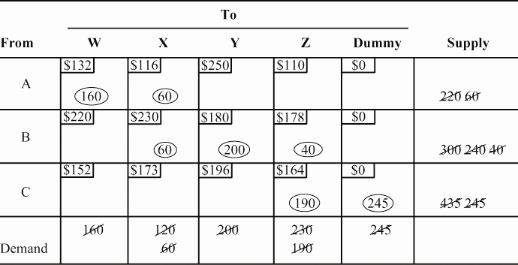
Cost = $132(160) + $116(60) + $230(60) + $180(200)
+ $178(40) + $164(190)
= $21,120 + 6,960 + $13,800 + $36,000 + $7,120
+ $31,160 = $116,160
C.10 (a),(b) Initial solution by northwest corner method; solution using the stepping-stone method:
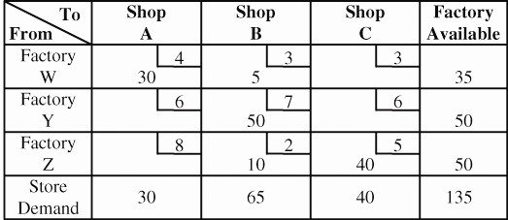

Improvement indices:
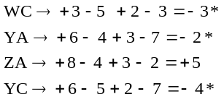
* Indicates that improvements can be made. The greatest improvement can be made by using route YC, which has an improvement index of –4. A total of 40 units can be moved along this new route.
Using route YC, we get:
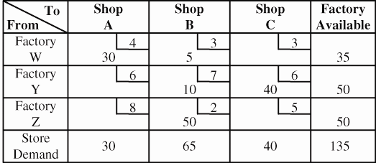

Improvement indices:
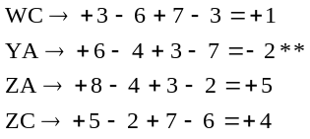
** Indicates that an improvement can be made. Note that the
most we can move around this route is 10 units.

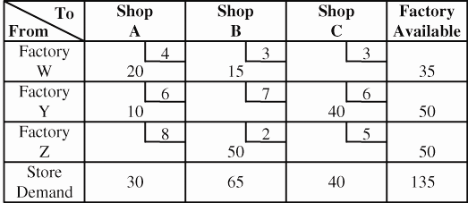
Using the route YA, we get:

C.11 (a) The initial solution using the northwest corner rule shows that degeneracy exists. The number of rows plus
the number of columns minus 1 (= 4 + 3 – 1) = 6. But the number of occupied squares is only 5. Refer to the numbers not circled.
Improvement Indices:
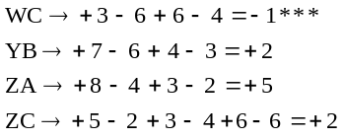
*** Indicates that an improvement can be made. Note that the
most we can move around this route is 20 units.
Using the route WC, we get:
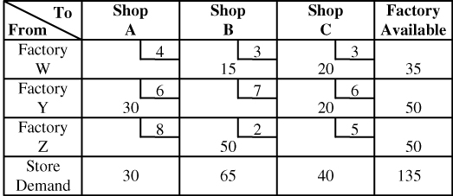
Improvement indices:
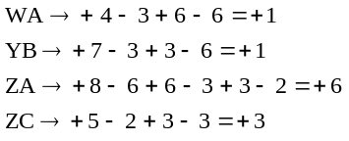
Because this is a minimization problem and all improvement
indices are positive, this solution is optimal at a cost of $505.
(b) To solve the problem, a zero will have to be placed in a square (such as 2-C). This will enable all unused paths to be closed.
(c) The optimal solution, through the use of Excel OM
or POM for Windows computer program, is circled.
Cost = $1,036.
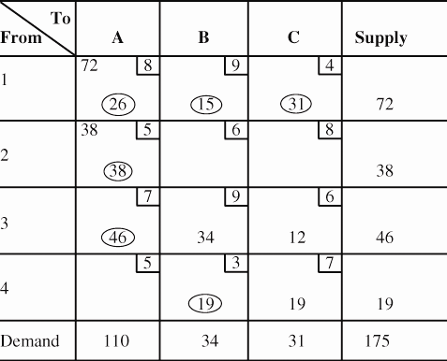

Alternate optimal solutions exist.
C.12 Initial table; initial solution by northwest corner method:
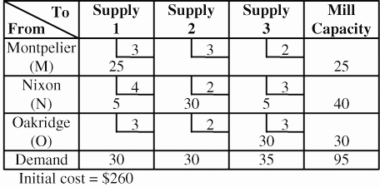
Improvement indices:
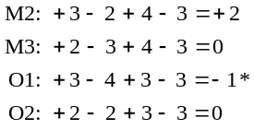
* Indicates that an improvement can be made.
Utilizing the route O1, we have:
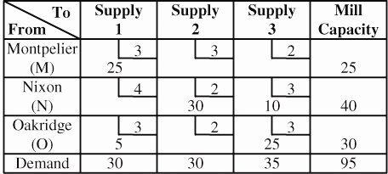
Calculating improvement indices:
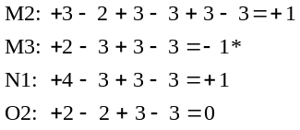
* Indicates that an improvement can be made.
Using the route M3, we have:
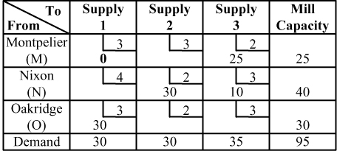
This solution is degenerate. To evaluate improvement indices, we must place a 0 in one of the unused squares.
Assume that we place the 0 in M1. We have improvement indices:
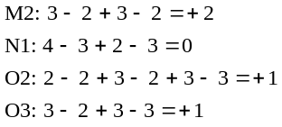
Because all improvement indices are positive or zero, this is an optimal solution. Because the improvement index for N1 is zero, we have an alternate solution using the route N1. Note, however, that the alternate solution involves merely moving the 0 to the square N1.
Total cost = (25 × 2) + (30 × 2) + (10 × 3)
+ (30 × 3) = $230
C.13 Solve two separate transportation problems. One will
include Philadelphia and the other will include Seattle. In both
cases, we need a dummy destination.
Philadelphia
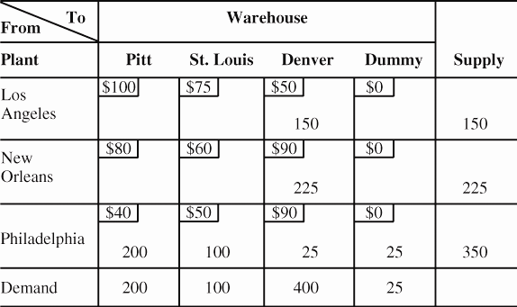
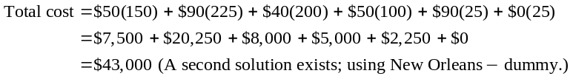
Seattle
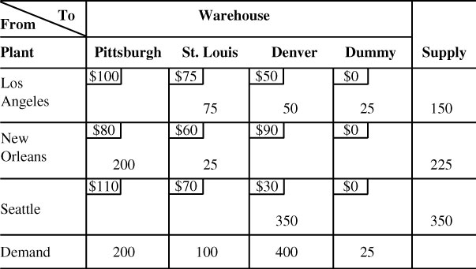
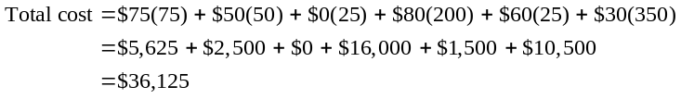
Therefore, shipping costs are lower for Seattle.
C.14 Initial solution—Northwest corner rule:
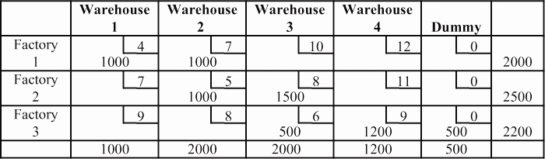
Optimal solution:
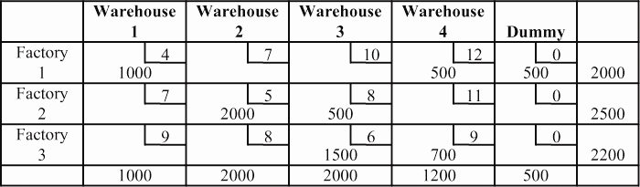
Optimal cost = $39,300
C.15 Considering East St. Louis, we have:
Initial solution—Northwest corner rule:
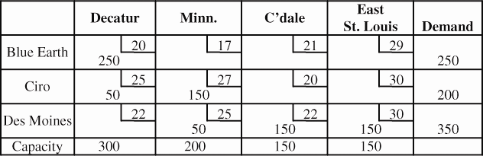
Optimal solution:
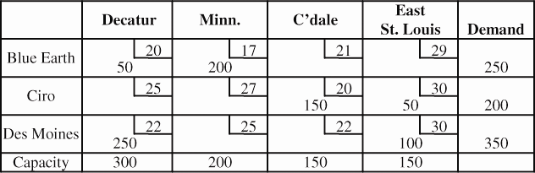
Optimal cost using East St. Louis: $17,400
Considering St. Louis, we have:
Initial solution—Northwest corner rule:
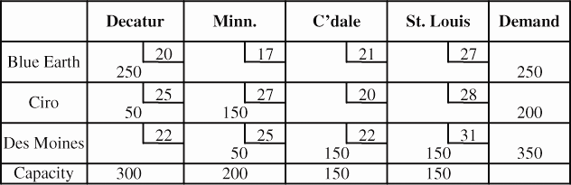
Optimal solution:
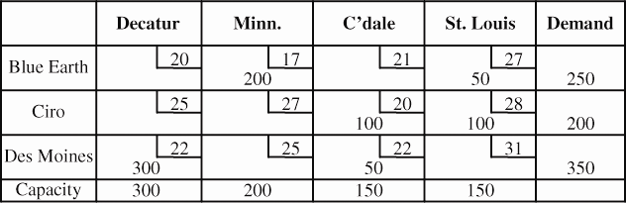
Optimal cost using St. Louis: $17,250
Therefore, St. Louis is $150 per week less expensive
than East St. Louis.
Note: In C.15 and C.16, columns are sources and rows are
destinations.
C.16 Considering East St. Louis, we have:
Initial solution—Northwest corner rule:
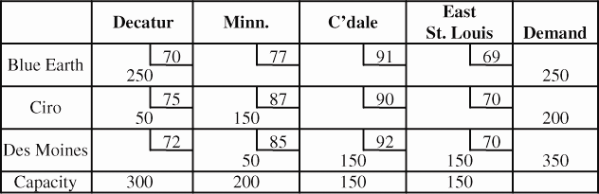
Optimal solution:
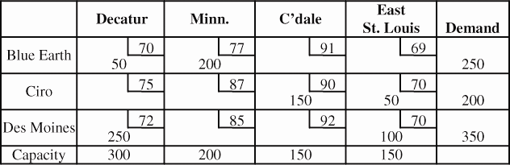
Optimal cost using East St. Louis: $60,900
Considering St. Louis, we have:
Initial solution—Northwest corner rule:
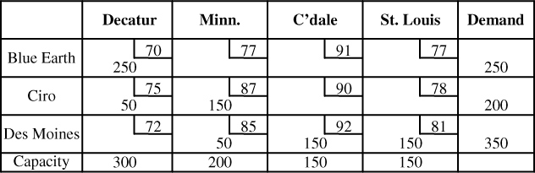
Optimal solution:
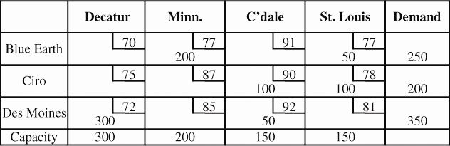
Optimal cost using St. Louis: $62,250
Therefore, East St. Louis is $1,350 per week less
expensive than St. Louis.

C.17 (a) | Dalton Pharmaceuticals  Mobile Opened  Shipments
 | From | To | Units | From | To | Units
 | Valdosta | Birmingham | 150 | Starkville | Jackson | 50
 | Valdosta | Raleigh | 200 | Starkville | Asheville | 150
 | Ocala | Orlando | 50 | Starkville | Columbia | 50
 | Ocala | Miami | 100 | Starkville | Orlando | 150
 | Ocala | Jacksonville | 150 | Durham | Columbia | 250
 | Augusta | Atlanta | 150 | Durham | Wilmington | 100
 | Augusta | Montgomery | 100 | Durham | Charlotte | 150
 | Augusta | Jacksonville | 150
 | Stuart | Miami | 200
 | Biloxi | New Orleans | 250
 | Biloxi | Orlando | 50
 | Biloxi | Mobile | 300
 | Minimum total cost = $8,100 Note: Alternate optimal solutions exist.

Dalton Pharmaceuticals
Tampa Opened
Shipments
From | To | Units | From | To | Units
Valdosta | Birmingham | 150 | Starkville | Jackson | 50
Valdosta | Raleigh | 200 | Starkville | Asheville | 150
Ocala | Miami | 100 | Starkville | Columbia | 50
Ocala | Jacksonville | 200 | Starkville | Orlando | 150
Augusta | Atlanta | 150 | Durham | Columbia | 250
Augusta | Montgomery | 100 | Durham | Wilmington | 100
Augusta | Jacksonville | 100 | Durham | Charlotte | 150
Augusta | Tampa | 50
Stuart | Miami | 200
Biloxi | New Orleans | 250
Biloxi | Orlando | 100
Biloxi | Mobile | 250
Minimum total cost = $9,300 Note: Alternate optimal solutions exist.

Dalton Pharmaceuticals
Huntsville Opened Shipments
From | To | Units | From | To | Units
Valdosta | Birmingham | 100 | Biloxi | Huntsville | 250
Valdosta | Raleigh | 200 | Starkville | Jackson | 50
Valdosta | Huntsville | 50 | Starkville | Asheville | 150
Ocala | Orlando | 100 | Starkville | Columbia | 50
Ocala | Miami | 100 | Starkville | Orlando | 150
Ocala | Jacksonville | 100 | Durham | Columbia | 250
Augusta | Atlanta | 150 | Durham | Wilmington | 100
Augusta | Birmingham | 50 | Durham | Charlotte | 150
Augusta | Jacksonville | 200
Stuart | Miami | 200
Biloxi | New Orleans | 250
Biloxi | Montgomery | 100
Minimum total cost = $8,400 Note: Alternate optimal solutions exist.
Comparing the optimal solutions for the three proposed locations:
Mobile $8,100
Tampa $9,300
Huntsville $8,400
Mobile should be selected as the new warehouse because it results in the lowest
shipping costs.

(b) | Dalton Pharmaceuticals  Ocala capacity increased to 500, with Mobile chosen  Shipments
 |  | From | To | Units | From | To | Units
 |  | Valdosta | Raleigh | 200 | Starkville | Asheville | 150
 |  | Ocala | Orlando | 250 | Starkville | Columbia | 50
 |  | Ocala | Miami | 100 | Durham | Columbia | 250
 |  | Ocala | Jacksonville | 150 | Durham | Wilmington | 100
 |  | Augusta | Atlanta | 150 | Durham | Charlotte | 150
 |  | Augusta | Montgomery | 100
 |  | Augusta | Jacksonville | 150
 |  | Stuart | Miami | 200
 |  | Biloxi | New Orleans | 250
 |  | Biloxi | Mobile | 300
 |  | Starkville | Jackson | 50
 |  | Starkville | Birmingham | 150
 |  | Minimum total cost = $7,100 Note: Alternate optimal solutions exist.

Dalton Pharmaceuticals
Ocala capacity increased to 500, with Tampa chosen
Shipments
From | To | Units | From | To | Units
Valdosta | Raleigh | 200 | Starkville | Birmingham | 150
Ocala | Orlando | 100 | Starkville | Asheville | 150
Ocala | Miami | 100 | Starkville | Columbia | 50
Ocala | Jacksonville | 300 | Durham | Columbia | 250
Augusta | Atlanta | 150 | Durham | Wilmington | 100
Augusta | Montgomery | 100 | Durham | Charlotte | 150
Augusta | Tampa | 150
Stuart | Miami | 200
Biloxi | New Orleans | 250
Biloxi | Orlando | 150
Biloxi | Tampa | 150
Starkville | Jackson | 50
Minimum total cost = $8,300 Note: Alternate optimal solutions exist.

Dalton Pharmaceuticals
Ocala capacity increased to 500, with Huntsville chosen
Shipments
From | To | Units | From | To | Units
Valdosta | Raleigh | 200 | Starkville | Asheville | 150
Ocala | Orlando | 250 | Starkville | Columbia | 50
Ocala | Miami | 100 | Durham | Columbia | 250
Ocala | Jacksonville | 150 | Durham | Wilmington | 100
Augusta | Atlanta | 150 | Durham | Charlotte | 150
Augusta | Montgomery | 100
Augusta | Jacksonville | 150
Stuart | Miami | 200
Biloxi | New Orleans | 250
Biloxi | Huntsville | 300
Starkville | Jackson | 50
Starkville | Birmingham | 150
Minimum total cost = $7,400 Note: Alternate optimal solutions exist.
Comparing optimal solutions:
Mobile $7,100
Tampa $8,300
Huntsville $7,400
No, it would not alter the decision made in Part A
because Mobile again has the lowest cost.

(c) | Dalton Pharmaceuticals  Florida shipping rates lowered, Ocala at 300 units, Mobile opened  Shipments
 | From | To | Units | From | To | Units
 | Valdosta | Birmingham | 150 | Starkville | Jackson | 50
 | Valdosta | Raleigh | 200 | Starkville | Asheville | 150
 | Ocala | Orlando | 50 | Starkville | Columbia | 50
 | Ocala | Miami | 100 | Starkville | Orlando | 150
 | Ocala | Jacksonville | 150 | Durham | Columbia | 250
 | Augusta | Atlanta | 150 | Durham | Wilmington | 100
 | Augusta | Montgomery | 100 | Durham | Charlotte | 150
 | Augusta | Jacksonville | 150
 | Stuart | Miami | 200
 | Biloxi | New Orleans | 250
 | Biloxi | Orlando | 50
 | Biloxi | Mobile | 300
 | Minimum total cost = $7,600 Note: Alternate optimal solutions exist.

Dalton Pharmaceuticals
Florida rates lowered, Ocala at 300 units, Tampa opened
Shipments
From | To | Units | From | To | Units
Valdosta | Birmingham | 150 | Starkville | Jackson | 50
Valdosta | Raleigh | 200 | Starkville | Asheville | 150
Ocala | Miami | 100 | Starkville | Columbia | 50
Ocala | Jacksonville | 200 | Starkville | Orlando | 150
Augusta | Atlanta | 150 | Durham | Columbia | 250
Augusta | Montgomery | 100 | Durham | Wilmington | 100
Augusta | Jacksonville | 100 | Durham | Charlotte | 150
Augusta | Tampa | 50
Stuart | Miami | 200
Biloxi | New Orleans | 250
Biloxi | Orlando | 100
Biloxi | Tampa | 250
Minimum total cost = $8,800 Note: Alternate optimal solutions exist.

Dalton Pharmaceuticals
Florida rates lowered, Ocala at 300 units, Huntsville opened
Shipments
From | To | Units | From | To | Units
Valdosta | Birmingham | 100 | Biloxi | Huntsville | 250
Valdosta | Raleigh | 200 | Starkville | Jackson | 50
Valdosta | Huntsville | 50 | Starkville | Asheville | 150
Ocala | Orlando | 100 | Starkville | Columbia | 50
Ocala | Miami | 100 | Starkville | Orlando | 150
Ocala | Jacksonville | 100 | Durham | Columbia | 250
Augusta | Atlanta | 150 | Durham | Wilmington | 100
Augusta | Birmingham | 50 | Durham | Charlotte | 150
Augusta | Jacksonville | 200
Stuart | Miami | 200
Biloxi | New Orleans | 250
Biloxi | Montgomery | 100
Minimum total cost = $7,900 Note: Alternate optimal solutions exist.
Comparing optimal solutions under conditions of Part A:
Mobile $7,600
Tampa $8,800
Huntsville $7,900
No, once again, Mobile should be selected.

Dalton Pharmaceuticals
Florida rates lowered, Ocala at 500, Mobile opened
Shipments
From | To | Units | From | To | Units
Valdosta | Raleigh | 200 | Starkville | Asheville | 150
Ocala | Orlando | 250 | Starkville | Columbia | 50
Ocala | Miami | 100 | Durham | Columbia | 250
Ocala | Jacksonville | 150 | Durham | Wilmington | 100
Augusta | Atlanta | 150 | Durham | Charlotte | 150
Augusta | Montgomery | 100
Augusta | Jacksonville | 150
Stuart | Miami | 200
Biloxi | New Orleans | 250
Biloxi | Mobile | 300
Starkville | Jackson | 50
Starkville | Birmingham | 150
Minimum total cost = $6,400 Note: Alternate optimal solutions exist.

Dalton Pharmaceuticals
Florida rates lowered, Ocala at 500, Tampa opened
Shipments
From | To | Units | From | To | Units
Valdosta | Raleigh | 200 | Starkville | Birmingham | 150
Ocala | Orlando | 100 | Starkville | Asheville | 150
Ocala | Miami | 100 | Starkville | Columbia | 50
Ocala | Jacksonville | 300 | Durham | Columbia | 250
Augusta | Atlanta | 150 | Durham | Wilmington | 100
Augusta | Montgomery | 100 | Durham | Charlotte | 150
Augusta | Tampa | 150
Stuart | Miami | 200
Biloxi | New Orleans | 250
Biloxi | Orlando | 150
Biloxi | Tampa | 150
Starkville | Jackson | 50
Minimum total cost = $7,600 Note: Alternate optimal solutions exist.

Additional Homework Problems
Dalton Pharmaceuticals
Florida rates lowered, Ocala at 500, Huntsville opened
Shipments
From | To | Units | From | To | Units
Valdosta | Raleigh | 200 | Starkville | Asheville | 150
Ocala | Orlando | 250 | Starkville | Columbia | 50
Ocala | Miami | 100 | Durham | Columbia | 250
Ocala | Jacksonville | 150 | Durham | Wilmington | 100
Augusta | Atlanta | 150 | Durham | Charlotte | 150
Augusta | Montgomery | 100
Augusta | Jacksonville | 150
Stuart | Miami | 200
Biloxi | New Orleans | 250
Biloxi | Huntsville | 300
Starkville | Jackson | 50
Starkville | Birmingham | 150
Minimum total cost = $6,700 Note: Alternate optimal solutions exist.
Comparing optimal solutions under conditions of Part B:
Mobile $6,400
Tampa $7,600
Huntsville $6,700
No, Mobile should again be selected.
Here are solutions to additional homework problems C.18–C.22 that appear on our Web site, at www.myomlab.com.
C.18
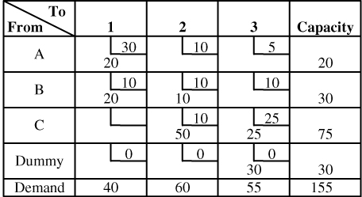
C.19
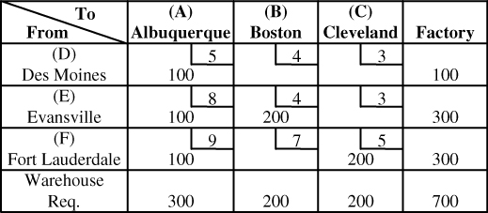
Improvement indices:
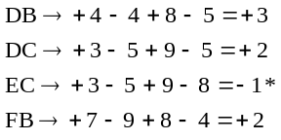
* Indicates an improvement can be made. Therefore, this iteration
is not optimal.

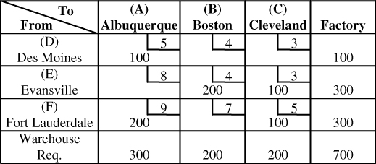

Improvement indices:
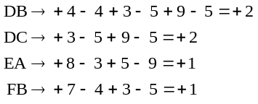
All improvement indices are positive, therefore, an optimal
has been reached.
Total cost = 100 × 5 + 200 × 4 + 100 × 3 + 200 × 9
+ 100 × 5 = $3,900
C.20 Table as given in example:

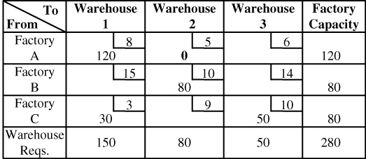
The existing solution is degenerate. Therefore, place a 0 (to
represent a “small” shipment) in one of the unused squares.
Placing a 0 in square A2, we find:
Improvement indices:
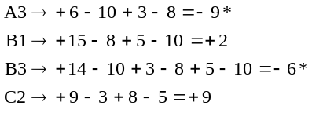
* Indicates that improvements can be made. The greatest improve-
ment can be made by using route A3, which has an improvement index of −9. A total of 50 units can be moved along this new route.

Using route A3, we get:

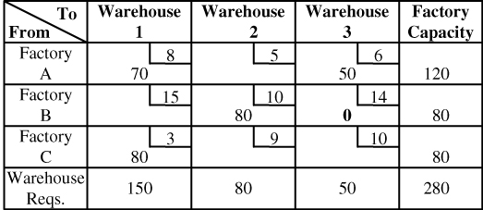
To evaluate the optimality of this iteration, place a 0 in one of the unused squares.
Placing the 0 in B3, we find:
Improvement indices:
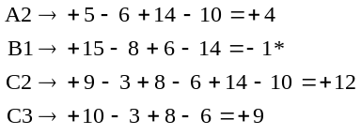
* Indicates that an improvement can be made. Note that the most we can move around this route is the 0 in B3. This would give us the following table:

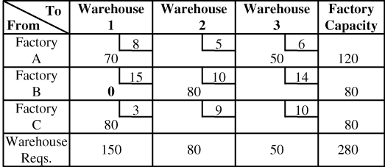
Evaluating improvement indices, we find:
Improvement indices:
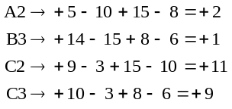
We now have an optimal solution. The student should realize that although it is not usually critical in which square we place the 0, placement in some squares will require more or fewer iterations than placement in others. (What would have happened had we put the original 0 in A3?)
Total cost = 70 × 8 + 50 × 6 + 80 × 10 + 80 × 3 = $1,900

C.21 (a) Transportation table with dummy plant, initial solution
by Northwest Corner:
(b) Stepping-Stone Method:
Improvement indices:
* Indicates that an improvement can be made. Note that the
most we can move around this route is 50 units.
Using route DA, we get
This solution is degenerate. To test for optimality, place
a 0 in one of the unused squares and apply the Stepping-
Stone method. Assume that the 0 is placed in XA:
Because all improvement indices are positive, the
initial solution is also the optimal solution.
Total cost = 200 × 6 + 0 × 10 + 100 × 5 + 75 × 6
+ 75 × 8 + 50 × 0 = $2,750

C.22 Considering Fontainebleau, we have:
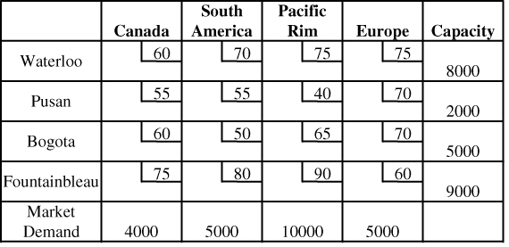
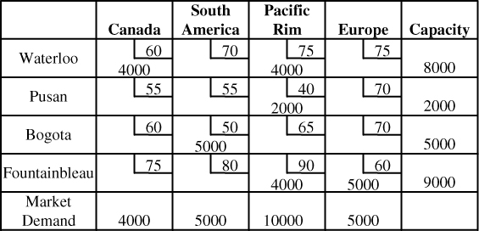
Optimal cost = $1,530,000
Considering Dublin, we have:
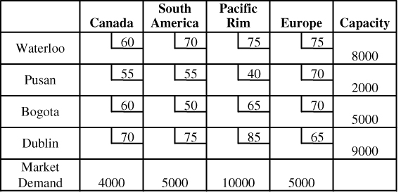
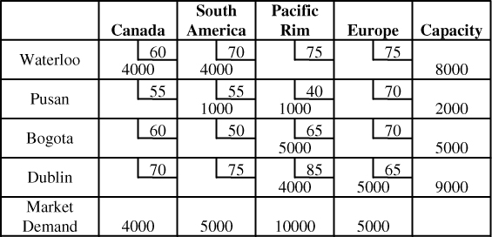

Optimal cost = $1,535,000
There is no difference in the routing of shipments, but
the Fontainebleau location is $5,000 less expensive than the
Dublin location. As a practical matter, changes in exchange rates, subjective factors, or evaluation of future intangibles may overwhelm such a small difference in cost.
Case Study
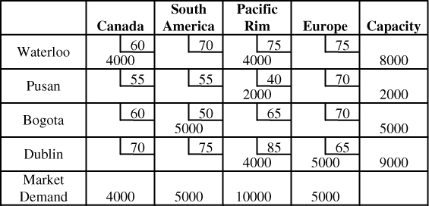
CUSTOM VANS, INC.
Where would you locate the two plants and why?
To determine whether the shipping pattern can be improved and where the two new plants should be located, the total costs for the whole transportation system for each combination of plants as well as the existing shipping pattern costs will have to be determined.
In the heading identifying the combination being discussed, Gary and Fort Wayne, will be omitted because they appear in every possible combination.
The derivation of total costs and optimal solutions for each combination is found on the succeeding pages. In summary:
Total cost: Detroit and Madison = $10,200
Madison and Rockford = $10,550
Detroit and Rockford = $11,400
Because the total cost is lowest in the Gary–Fort Wayne–Detroit–Madison combination ($10,200), then the new plants should be located in Detroit and Madison. This system is also an improvement over the existing pattern, which costs $9,000, for now an extra 300 units can be shipped at an additional cost of $1,200.
In terms of average total costs:
Status quo: $9,000 for 450 units = $20.00/unit
Proposed: $10,200 for 750 units = $13.60/unit
Thus, the two new plants would definitely be advantageous, both in terms of demand and in minimizing transportation costs.
(a) Existing pattern:
Initial solution—Northwest corner rule:
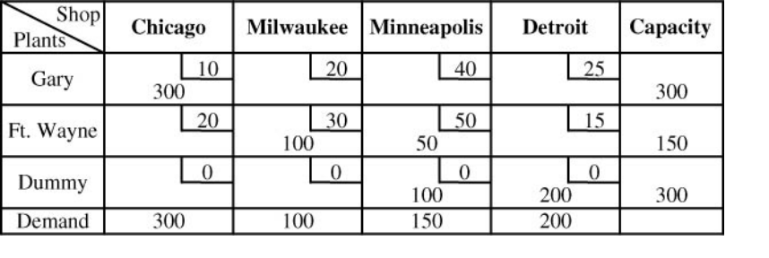

Currently implemented solution:
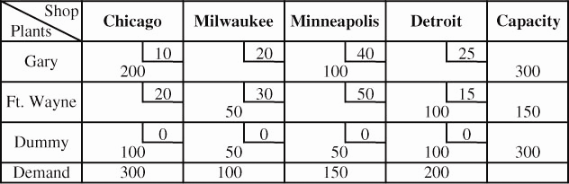

Total cost = 200 × 10 + 50 × 30 + 40 × 100 + 100 × 15
= $9,000
(b) Considering Detroit and Madison:
Initial solution—Northwest corner rule:
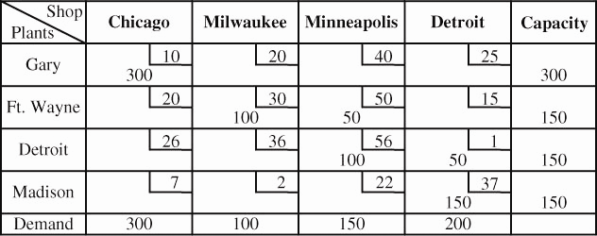

Note: Because a plant at Detroit could purchase a gallon of fiberglass for $2 less than any other plant, and one Showerific takes 2 gallons of fiberglass, a systems approach to transportation warrants that $4 (2 × 2) be deducted from each price quoted in the case for shipments from Detroit.
Because a plant at Madison could hire a laborer for $1 less per hour than the other plants, and one Showerific takes 3 labor hours to build, then $3 (3 × 1) should be deducted from each price quoted for shipments from Madison.

Optimal solution:
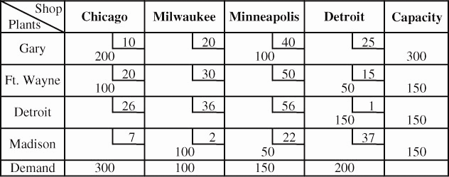

Total cost = 200 × 10 + 100 × 20 + 100 × 2 + 100 × 40
+ 50 × 22 + 50 × 15 + 150 × 1 = $10,200

(c) Considering Madison and Rockford:
Initial solution—Northwest corner rule:
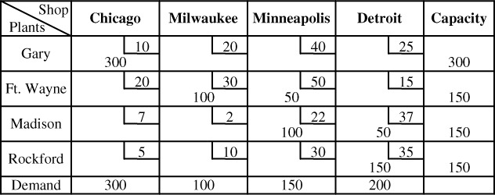
Optimal solution:
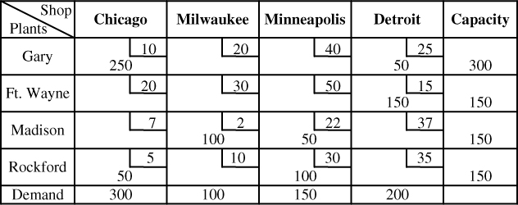
Total cost = 250 × 10 + 50 × 5 + 100 × 2 + 22 × 50
+ 100 × 30 + 50 × 25 + 150 × 15 = $10,550

(d) Considering Detroit and Rockford:
Initial solution—Northwest corner rule:
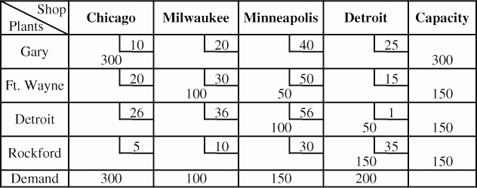

Additional Case Study*
Optimal solution:
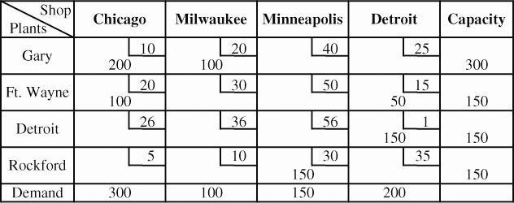
Total cost = 200 × 10 + 100 × 20 + 100 × 20 + 50 × 15 + 150 × 1
+ 150 × 30 = $11,400

CONSOLIDATED BOTTLING: B
The approach to this case is very straightforward. The data set contains an 18-by-18 table. Six of the rows have a 0 for the supply. Students need to replace each 0 first with 130 and then with 180 and solve for the total cost, as shown in the table.
City | Total Cost with 130 | Total Cost with 180
Columbus | 3,556 | 3,406
Indianapolis | 3,405 | 3,205
Miami | 3,674 | 3,674
Montreal | 3,511 | 3,511
Raleigh | 3,779 | 3,729
San Francisco | 3,375 | 3,175
Clearly, the solution is to add 180 to San Francisco. The new and old routes can be compared from the solution Tables 1 and 2,
below. (Note: All numbers are in thousands.)
Optimal cost = 3,175 miles
Table 1:

* Solution to case that appears on our Companion Web site,
www.pearsonhighered.com/heizer.

Shipments
From | To | Units | From | To | Units
Albuquerque | Albuquerque | 24 | Denver | Denver | 51
Albuquerque | Los Angeles | 124 | Detroit | Detroit | 121
Baltimore | Baltimore | 62 | Houston | Houston | 123
Baltimore | Columbus | 53 | Kansas City | Chicago | 154
Baltimore | Detroit | 30 | Kansas City | Indianapolis | 36
Baltimore | Miami | 33 | Kansas City | Kansas City | 50
Baltimore | Montreal | 42 | Los Angeles | Los Angeles | 157
Baltimore | Raleigh | 12 | Portland | Portland | 38
Boston | Boston | 64 | Portland | San Francisco | 71
Boston | Montreal | 79 | St. Paul | Indianapolis | 38
Chicago | Chicago | 182 | St. Paul | St. Paul | 30
Dallas | Dallas | 84
Minimum total cost = 4,037 Note: Alternate optimal solutions exist.

Table 2:
Shipments
From | To | Units | From | To | Units
Albuquerque | Albuquerque | 24 | Dallas | Dallas | 84
Albuquerque | Los Angeles | 15 | Denver | Denver | 51
Baltimore | Baltimore | 62 | Detroit | Detroit | 121
Baltimore | Chicago | 38 | Houston | Houston | 123
Baltimore | Columbus | 53 | Kansas City | Chicago | 116
Baltimore | Detroit | 30 | Kansas City | Indianapolis | 74
Baltimore | Miami | 33 | Kansas City | Kansas City | 50
Baltimore | Montreal | 42 | Los Angeles | Los Angeles | 157
Baltimore | Raleigh | 12 | Portland | Portland | 38
Boston | Boston | 64 | St. Paul | St. Paul | 30
Boston | Montreal | 79 | San Francisco | Los Angeles | 109
Chicago | Chicago | 182 | San Francisco | San Francisco | 71
Minimum total cost = 3,175 Note: Alternate optimal solutions exist.

